11/14/16 Assembly

Class Notes

Creating frame pointer

* Ex)
  + 

When passing values

* We can use a variable
  + Ex) x: .word 0
* Or we could create a frame of 5 bytes, and access as [sp+4]

The values we pass are not random, but determined by the space needed for items + 4 bytes for the next place in stack

* Ex)
  + 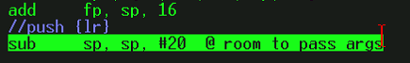

S registers

* For single precision (32 bits)
  + S0 – S1 => d0
  + S2 – S3 => d1
  + S4 – S5 => d2

D Registers

* 64 bit double registers

Adding values in s registers

* Uses f32 to calculate floating 32 bit values
* Ex)
  + 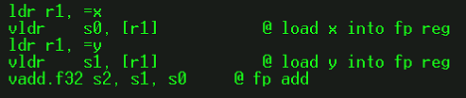
* F64 calculates 64 bit values
* S32 – signed 32 bit int
* U32 – unsigned 32 bit int